REVISION LAB
1. BASIC PYTHON PROGRAMMING
Write a program that reads a file, "input.txt", and replaces all occurrences of a specific word with another word. The words to be replaced and the replacement word should be given as inputs during the runtime. Write the updated content into another file which will be created at runtime.
Example:
Input File:
I love programming. Programming is fun. Programming helps in solving problems. I love it.
Inputs at runtime:
- Word to replace: "Programming"
- Replacement word: "Coding"
- Do you want to continue? Yes
- Word to replace: "love"
- Replacement word: "like"
- Do you want to continue? No
- Exits
Output File:
I like coding. Coding is fun. Coding helps in solving problems. I like it.
2. CISCO PACKET TRACER
Implement the following topology and use BGP protocol.
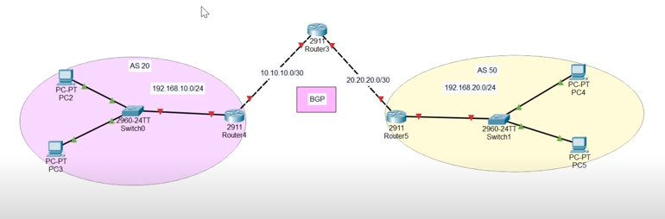

Helping Video:
https://youtu.be/WvmfhFH9PlU?si=ombkU2rvyzR_B0BU

